EX NO: 2 | OOPS CONCEPTS

AIM:
To implement Object-Oriented Programming concepts including encapsulation, inheritance, polymorphism through Bank Account Management and Employee Payroll Systems.
Exercise 1: Bank Account Management System
# ===============================
# Exercise 1: Bank Account System
# ===============================

# Base class
class BankAccount:
def __init__(self, account_holder, initial_balance):
# Public data member
self.account_holder = account_holder

# Private data member (Encapsulation)
self.__balance = initial_balance

# Method to deposit money
def deposit(self, amount):
if amount > 0:
self.__balance += amount
print(f"₹{amount} deposited successfully.")
print(f"Updated Balance: ₹{self.__balance}")
else:
print("Deposit amount must be positive.")

# Method to withdraw money
def withdraw(self, amount):
if amount <= self.__balance:
self.__balance -= amount
print(f"₹{amount} withdrawn successfully.")
print(f"Remaining Balance: ₹{self.__balance}")
else:
print("Error: Insufficient balance.")

# Getter method to access private balance
def get_balance(self):
return self.__balance

# Subclass SavingsAccount
class SavingsAccount(BankAccount):
def __init__(self, account_holder, initial_balance, interest_rate):
# Call base class constructor
super().__init__(account_holder, initial_balance)
self.interest_rate = interest_rate

# Overriding withdraw method (Polymorphism)
def withdraw(self, amount):
if amount > 20000:
print("Error: Maximum withdrawal limit is ₹20,000 per transaction.")
else:
super().withdraw(amount)

# Method to add interest
def add_interest(self):
interest = self.get_balance() * (self.interest_rate / 100)
self.deposit(interest)
print(f"Interest of ₹{interest:.2f} added.")

# ===============================
# Testing Exercise 1
# ===============================

print("\n--- BankAccount Testing ---")
acc1 = BankAccount("Pitambar", 50000)
acc1.deposit(10000)
acc1.withdraw(15000)
print("Final Balance:", acc1.get_balance())

print("\n--- SavingsAccount Testing ---")
sav1 = SavingsAccount("Pitambar", 80000, 5)
sav1.withdraw(25000) # Should fail due to limit
sav1.withdraw(15000) # Should succeed
sav1.add_interest()
print("Final Balance:", sav1.get_balance())

OUTPUT:
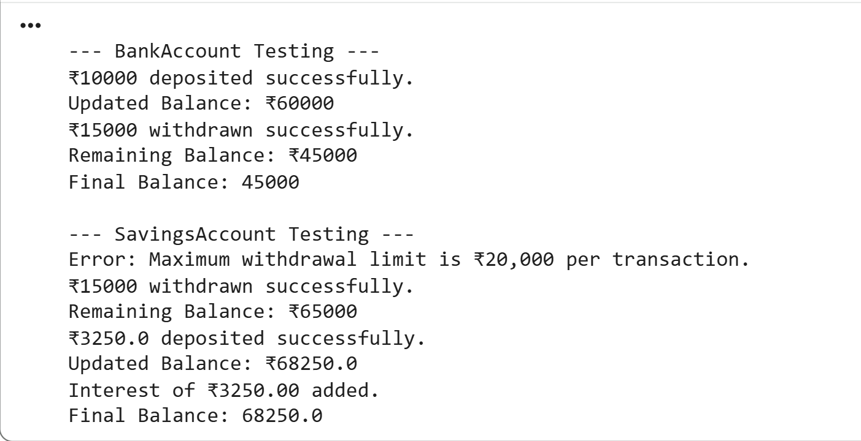
Exercise 2: Employee Payroll System
# ===============================
# Exercise 2: Employee Payroll System
# ===============================

# Base class
class Employee:
def __init__(self, name, emp_id):
# Protected data members
self._name = name
self._emp_id = emp_id

# Method to calculate salary (to be overridden)
def calculate_salary(self):
print("Salary calculation not defined for base Employee class.")

# Method to display employee details
def display_details(self):
print(f"Employee Name: {self._name}")
print(f"Employee ID: {self._emp_id}")

# Full-time employee subclass
class FullTimeEmployee(Employee):
def __init__(self, name, emp_id, monthly_salary):
super().__init__(name, emp_id)
self.monthly_salary = monthly_salary

# Overriding calculate_salary
def calculate_salary(self):
return self.monthly_salary

# Part-time employee subclass
class PartTimeEmployee(Employee):
def __init__(self, name, emp_id, hours_worked, rate_per_hour):
super().__init__(name, emp_id)
self.hours_worked = hours_worked
self.rate_per_hour = rate_per_hour

# Overriding calculate_salary
def calculate_salary(self):
return self.hours_worked * self.rate_per_hour

# ===============================
# Testing Exercise 2 (Polymorphism)
# ===============================

employees = [
FullTimeEmployee("Pitambar", 101, 50000),
PartTimeEmployee("Manoj", 102, 120, 400)
]

for emp in employees:
print("\n------------------------")
emp.display_details()
print("Employee Type:", emp.__class__.__name__)
print("Calculated Salary: ₹", emp.calculate_salary())

OUTPUT:
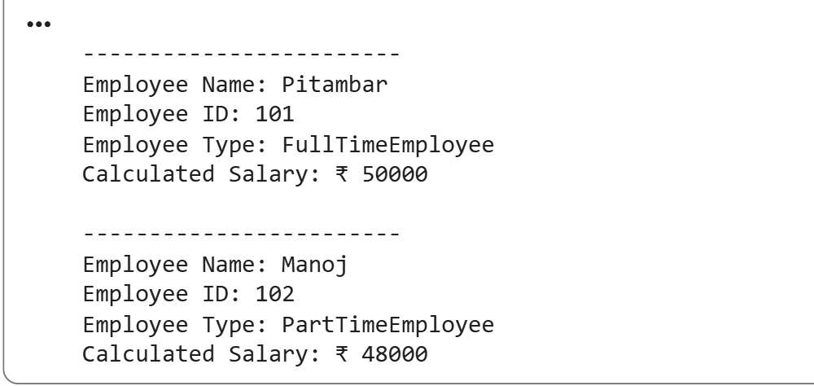

RESULT:
Thus , OOPS concept was successfully implemented in both the exercises.

